**Form 21**

**Power of authority to agent**

(Section 43)

In connection with Filing, Prosecution and Registration of Design Application,

We, “**KUMARAGURU COLLEGE OF TECHNOLOGY** “, having Nationality of India of the address, Coimbatore, Tamil Nadu 641049, INDIA.

AND

I, “Lakshmi Narayanan V,” having Nationality of India of the address, Assistant Professor, Department of Academics, Kumaraguru College of Technology, Coimbatore, Tamil Nadu 641049, INDIA.

AND

I, “Kishore N M,” having Nationality of India of the address, Department of Aeronautical Engineering, Kumaraguru College of Technology, Coimbatore, Tamil Nadu 641049, INDIA.

AND

I, “Pavith P,” having Nationality of India of the address, Department of Civil Engineering, Kumaraguru College of Technology, Coimbatore, Tamil Nadu 641049, INDIA.

AND

I, “Sri Arunachaleeshwaran M,” having Nationality of India of the address, Electronics and Communications Engineering, Kumaraguru College of Technology, Coimbatore, Tamil Nadu 641049, INDIA.

AND

I, “Aparna R M,” having Nationality of India of the address, Department of Civil Engineering, Kumaraguru College of Technology, Coimbatore, Tamil Nadu 641049, INDIA.

AND

I, “Shamyuktha V P,” having Nationality of India of the address, Department of biotechnology, Kumaraguru College of Technology, Coimbatore, Tamil Nadu 641049, INDIA.

AND

I, “Anitha N,” having Nationality of India of the address, Assistant Professor, Department of Mathematics, Kumaraguru College of Technology, Coimbatore, Tamil Nadu 641049, INDIA.

AND

**of 4A IP Solution, Altf Expressway, 7th Floor, Express Trade Tower 2, Sector 132, Noida, Uttar Pradesh, India 201301**,

To act as our agent to receive all notices, requisitions and communications until further notice and to appoint a substitute or substitutes as and when necessary.

And we revoke all previous authorizations, if any, in respect of the same matters or proceedings given by us.

Dated this 20th day of September 2023,

Signature

(KUMARAGURU COLLEGE OF TECHNOLOGY)

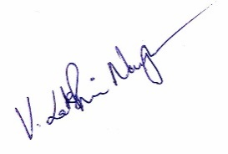

Signature

(Lakshmi Narayanan V)

Signature

(Kishore N M)

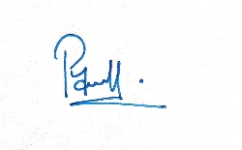

Signature

(Pavith P)

Signature

(Sri Arunachaleeshwaran M)

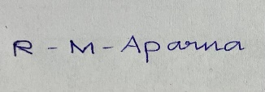

Signature

(Aparna R M)

Signature

(Shamyuktha V P)

Signature

(Anitha N)

To

The Controller of Designs,

The Patent Office, Kolkata.